Portfolio: Writing and Editing

Polly St John Hughes

Sample of Editing
Before & after editing I did with one of my tutoring students: part of her application for college.
5. Describe the most significant challenge you have faced and the steps you have taken to overcome this challenge. How has this challenge affected your academic achievement?

Before:
It was a sunny morning in the mid-August, I walked into a strange school with my dad and line up in front of the building and waiting for the teacher to come. My dad said to me with concern, “don’t be afraid, everything will be ok,” and walked away from me to the school gate. Immediately, I felt uncomfortable and helplessness. Everyone around me is different races that I never see before and all talk in a language that I rarely know, English. My heart was pounding and subconsciously just want to run out of the gate and find my dad. But I can’t, I can’t do that, I know I have to be brave and just “Go for it.”
As you can see, my biggest challenge or the turning point of my life was coming to the U.S. as an immigrant. My family wants to have a better life and jobs in the U.S. However, as a 10-year-old little girl, I faced the hardest challenge that I never encountered before throughout my life. At that time, I was struggling in school, don’t know how to read, write and speak in English. Unfortunately, no one wants to befriend me. I also need to learn American culture, the food there, the environment here in order to become a real American. My mom and my dad barely know any English. I feel very helplessness no one can help me with my homework, no one to talk to besides my family. Sometimes I cry in school and at home. It was hopeless that hits me very hard that I can’t endure. As a young girl, I experimented hardship that other children never encounter in their entire life.
Fortunately, as the adaptive phase pass, I start to enjoy learning English and find the new version of myself. I tried to watch American TV shows, books, magazines and find interesting activities that help me learn English. I have the most amazing teacher that cares about me and helps me overcome my struggles. Also, I meet a group of wonderful friends in school and outside the school. It is amazing! I feel passionate, happy and upbeat. I start to understand my mom and my dad’s hardworking and how they want to give our family better lives. I start to study hard in school and build myself into a better person. I am thankful for my family, teachers, friends, and others who assisted me out. But the most important person that I want to thank you is myself, the one who was brave, never give up and overcome all those hardships.

After:
It was a sunny morning in mid-August. I walked into a strange school with my dad and stood in front of the building, waiting for the teacher. The students around me were different colors and races. Everyone spoke English, which I barely knew. My dad said, “Don’t be afraid, everything will be ok,” and walked away. I immediately felt uncomfortable and helplessness. My heart was pounding; subconsciously I wanted to run away and find my dad. But I couldn’t do that, I knew I had to be brave and just “Go for it!” As a 10-year-old little girl, the biggest challenge of my life was coming to the U.S. as an immigrant.
Once in school, didn’t know how to read, write and speak in English. At first, no one wanted to befriend me. I had no one to help me with my homework and or talk to besides my family. At times I cried in school and at home, saying to myself; it is hopeless, so hard and I can’t endure. I had to learn about American culture, food, and the environment here in order to become a real American. As a young girl, I experienced hardships that other children would never encounter in their entire life.
As the adaptive phase passed, I started to enjoy learning English and finding a new version of myself. I watched American TV shows and read books and magazines trying to find interesting activities that helped me to learn English. I had the most amazing teachers that cared about me and helped me to overcome my struggles. I gradually developed wonderful friendships in and outside of school. It was amazing! I started to feel passionate, happy and upbeat again. I then understood my parent's desire to give our family a better life in America, which inspired me to study harder in school and build myself into a better person. Now I am so thankful to my family, teachers, friends, and others who have and continue to assist me. However, the most important person that I want to thank is myself, the one who was courageous, never gave up in the face of adversity, and overcame all those hardships.

Auto-Biographical Book Project
Before & after editing on a book with one of my editing clients.

Before
Then, on January 2, 1995, I got the call at five in the morning from my mother. My brother was in the ICU in an Oakland hospital where he had been admitted the night before. His fever was 107 degrees Fahrenheit and his blood pressure had been 135/17 earlier in the night. My mom had gone to see my brother at his home and had been shocked when he opened the door, gaunt to the point of looking skeletal. She had immediately driven him to the ER where they told him that they “might be admitting a dead man.” He had a strep throat infection that disseminated throughout his bloodstream and was already in a state of sepsis. They had begun administering IV fluids, but hadn’t ascertained that his kidneys had already shut down. The fluids had no way to flush the now-dying bacteria of his body since they had also started him on IV antibiotics at the same time. I left my house as soon as I packed a bag. I was determined to chant my brother back to health so I packed lots of chanting tapes and a couple of my metal idol statues along with pictures of the guru that I was planning to set up in my brother’s ICU room. I had really forgotten about my cry out to God in November. I drove toward the Bay Area alone, which was beginning to be more and more comfortable for me since by now I usually wanted to avoid being around Tom and the girls. I was exhausted from trying unsuccessfully to make them always do what I wanted and increasingly ashamed of my poor treatment of them that I seemed helpless to change. I counted at least seven rainbows that appeared to be directly over my path as I traveled down the mountain and into the Bay Area and had a strangely mixed sense of foreboding and hope.

After

On January 2, 1995, I got the call at five in the morning from my mother. She had gone to see my brother at his home. When he opened the door, gaunt to the point of looking skeletal, she immediately drove him to the ER, where they told her that they “might be admitting a dead man.” He had a fever of 107 degrees Fahrenheit and a strep throat infection that had disseminated throughout his bloodstream. He was already in a state of sepsis and his blood pressure was 135/17. He was immediately admitted into ICU. There they began administering IV fluids and antibiotics. However, they soon realized his kidneys had already shut down. He was in a life and death situation.

I was determined to chant my brother back to health. I left my house as soon as I packed a bag, which included: chanting tapes and a couple of my metal idol statues along with pictures of the guru that I was planning to set up in my brother’s ICU room. I had totally forgotten about my plea to God in November. I drove toward the Bay Area alone, which was beginning to be more the norm for me, as I was purposely avoiding my husband and the girls. My continued dysfunctional behaviors towards them were too painful for me or them to endure. My solution was avoidance.

I counted at least seven rainbows that appeared to be directly over my path as I traveled down the mountain into the Bay Area with a strangely mixed sense of foreboding and hope. Imagine my surprise when I arrived in my brother’s ICU room fully masked, gloved, and gowned, and noticed that my mother had placed a large crucifix on the wall facing my brother’s bed where he laid on ice in order to get his fever down. My brother was intubated, his body was swollen because the doctors had started giving him IV fluids before they realized that his kidneys had already shut down. A priest had come sometime in the middle of the night to administer the last rites of the Roman Catholic Church to him.

Website Design and Content
My Author’s Website – Veronica Hughes is My Pen Name
Pearlofgreatpriceorthodox.com
Sample of my Home Page Content
Autobiographical Writing Sample
Auto-biographical passage taken from The Pearl of Great Price, The Spiritual Journey of a New Age Seeker to the Light of Christ and the Eastern Orthodox Church, Chapter I, Seeking a New Life in America
In Velva, Father’s family raised most of their own vegetables in a garden they shared with neighbors. At times during the winter they did not have enough food. One of my aunts told me that as children they looked forward to the birth of other children, because births in the village, or holy days of the church, were the only times their family ate meat. Frequently, the children went without shoes, and all of them worked from the age of six to help make ends meet, laboring as ﬁeld hands or carrying wood on their heads for miles.
As time went on, my grandfather arranged for the eldest son, Mario, to come to America ﬁrst, and as an American he fought in World War I. My father and aunts grew up in Italy during the war, and life was especially diﬃcult for them during this period. Food shortages aﬀected everyone - villagers and prisoners at a nearby POW camp, alike. My aunts often took many risks, as did the other villagers, to secretly bring food to the starving Allied prisoners. If chronic hunger wasn’t enough suﬀering, all my paternal ancestors also managed to survive the ﬂu epidemic that struck Europe and the United States from which at least half their village perished.
Life in rural Italy revolved around their local church and the cathedral at the top of the mountain behind them. My aunts would tell me how they walked in processions, carrying icons and statues of Mary, Christ’s mother. The family frequently went to Mass, sometimes daily. Because of the proximity of our family to their local church, and the absence of a father, the parish priest occasionally helped to discipline my father and his older brother. An unfortunate consequence of this was that my father resented the intrusion and later avoided both priests and church attendance.
When my grandfather ﬁnally arranged to bring the rest of his family to the United States in 1921 on a ship named America, they almost perished on their voyage. In later years, my aunt frequently told the story of the harrowing experience tossing and shaking on the ship during a raging storm with hurricane force winds. The passengers and crew cowered as a thirty-foot wave hit their ship. It broke open the parlor room door where many people, including my family, had gathered for safety. The ship tilted as seawater crashed into the room. My father lost his footing and was just about to be carried overboard when someone grabbed him and saved his life! The crew gave the passengers lifejackets and sent them to their rooms, but my family went to bed that night not knowing if they would survive the storm. All the papers in the United States and in Italy reported that their ship had sunk, but then several days later the America sailed into Ellis Island with all safe on board. What a way to start life in America!

My Blog
https://pearlofgreatpricebook.wordpress.com/
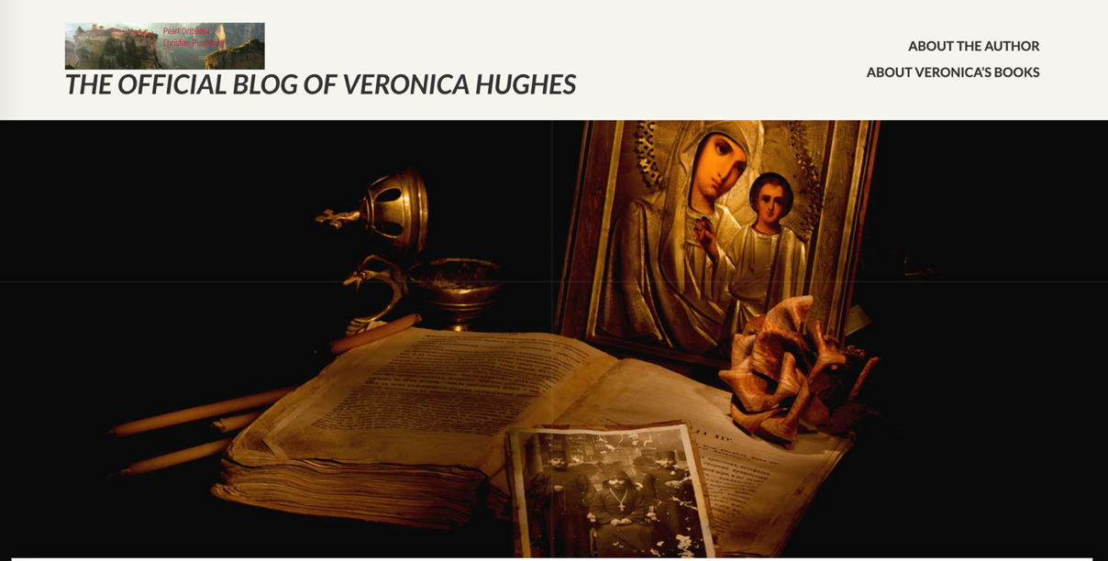
Content from a blog post
Off it went into the night with Michael and his brothers... this old RV/truck was the source of amazement to my husband and I as it was driven off our property after 9 years. We obtained this old RV from a dear friend who was relieved to get it off his property for nothing. My husband found an old, but good Chevy truck to carry it. We fixed it up inside, rewired it and then took it out for a long weekend.
That night we stayed in our first RV park and hooked up to the parks electrical system. Everything seemed fine until I was settling in to go to sleep in the area above the cab. I accidentally banged my knee on the cab ceiling and sparks flew! So, we unplugged ourselves from the electrical hook up. Then we took it to the beach and as we made a rather sharp turn, we heard a loud prolonged wrenching sound. Part of the siding was pulled loose and hanging. On the way home I was in the back of the RV, resting. My husband had bought us walky talkies so we could communicate with each other when he was driving. Suddenly there was smoke and a fire in the cabin. I grabbed my walky talky and yelled, "Fire in the hold! May Day! May Day!" The battery wires had caught on fire.
After these three incidents we realized that the only safe place for this RV was on our property in Platina, CA. The stove did work and we used it for years while we were building our home here. Greg built a deck around it and we cooked many a good meal in it. We called it the chuck wagon. The truck served us as well while it was detached from its camper until the ground squirrels ate some of the hosing and wiring. It came time to move the RV camper top and my niece Brittany and her beau came to our aid. They helped us to somewhat repair the truck and move the camper back onto the RV. Greg drove it down a ways - black smoke trailing to the middle of our land where it died. There is sat there for 2 years. We had no idea how to get it off our property due to its mechanical problems. Who would want such an old, useless RV? It seemed an impossible task.
Then a young boy named Michael was visiting the monastery up the road from us. He really liked the old RV/truck and Greg said, "When you grow up a little more - you can have it." Never thinking that anything would truly come of it. About a month later we arrived back from a walk with our dogs on a Sunday afternoon and who greets us, but Michael and his younger brother! Michael said, "I brought my older brother, Dan, who is a mechanic and he brought a friend. They are working on the truck and we will be taking it home tonight!" Our mouths dropped open! "OK, wonderful, do you need anything?" We asked. "No.", replied Dan. Four hours later, after we gave them money for gas and sandwiches, Dan signed the title papers. Off they drove with the truck purring and no black smoke in its wake. We sat on our porch totally amazed. Then Greg told me that he had prayed to the Mother of God asking for help to get the old RV/truck off our property about a week prior. Just another day in our blessed life on our land in Platina, CA. Glory to God for all things! Oh, the power of prayer!
My Resume
